Asia-China-Mirror-Yueh-16 bosses

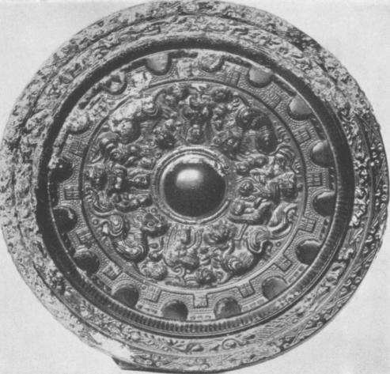

Wu or Yiieh Mirror Di.: 11,5 cm.  
Formerly *Ostasiatische Kunstabteilung, Museum, Berlin*

*Wu* or *neh* mirror, which was made from the second century A. D. onwards in the coastal region of Southern China. The large boss (fig. 13) indicates that the canopy, of which it was the copy, is a heavy one and the main decorated zone with its deep relief suggests that it is the image of a carved wooden disc. In this case it seems fairly certain that the construction had to be supported by a central post. In terms of a building: the boss corresponds to the apex of the roof, the carved portion to the vault of the building, either a round tower or a round hall. The most interesting part is the next zone: a band decorated with semi-circular arcs in high relief which alternate with flat squares. This band represents the base of the roof construction and the semi-circular arcs stand for the ends of posts or pillars half hidden in the wall; the squares are the ends of brackets placed on both sides of the posts. The patterns on the rim of the mirror again correspond to the decoration of the walls. The type of building imitat­ed in this canopy is thus very different from those on the other mirrors. It may be suggested that this more solid type of building was typical of the architecture of the Southern regions of China, while the lantern ceiling, tent or yurt-like constructions, were more favoured in the Northern and North-western parts of China.

The decoration of this mirror can also be interpreted in terms of a canopy. The carved portion was probably convex and was encompassed by a broad band. The semi-circular motifs and the squares mark the end of stays and props supporting the heavy cover from below.